Traffic Light Controller with Pedestrian Crossing
Simulation Output

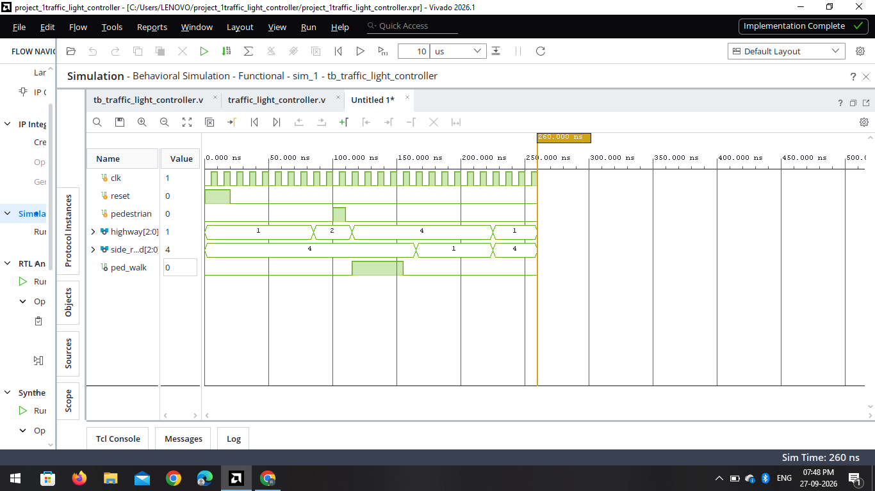
Figure 1: Vivado Simulation Waveform

RTL Schematic

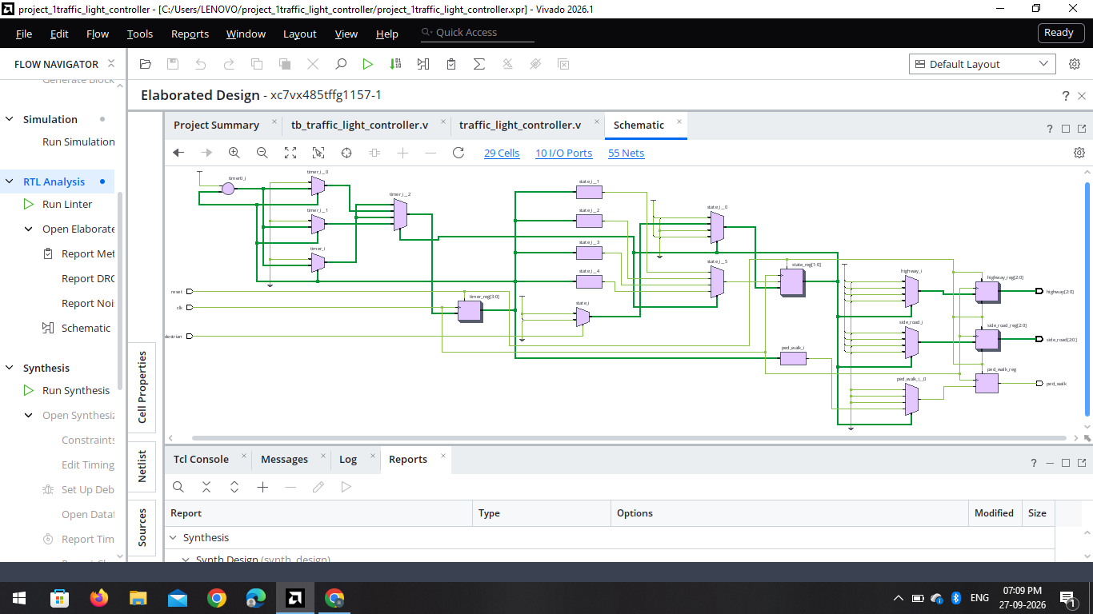
Figure 2: Vivado RTL Schematic

Console Output

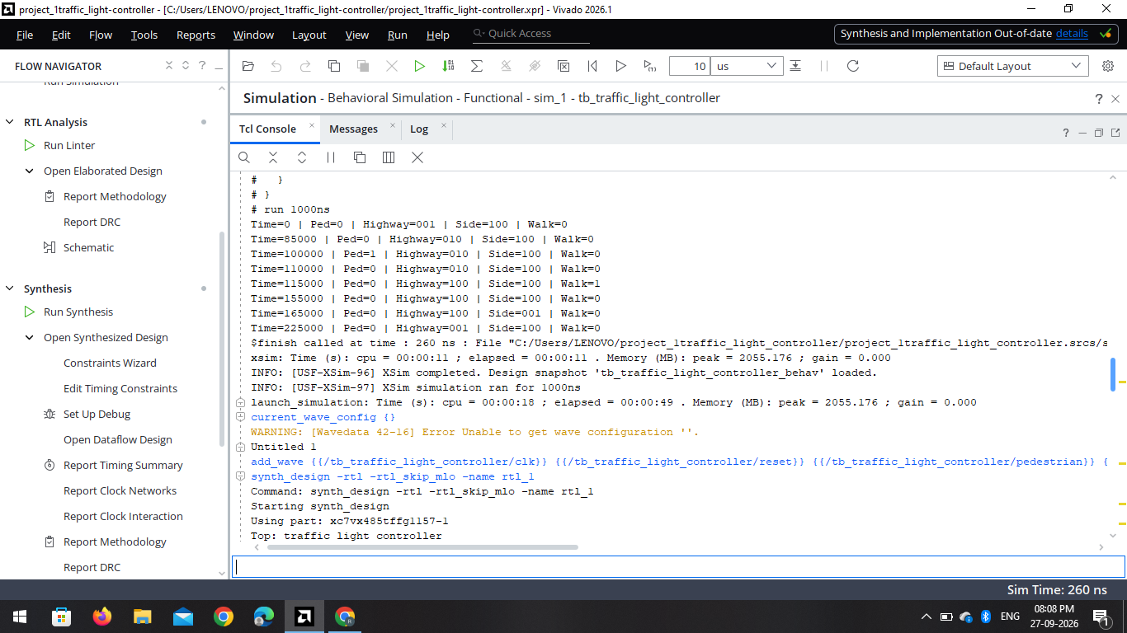
Figure 3: Console Output

Power Analysis

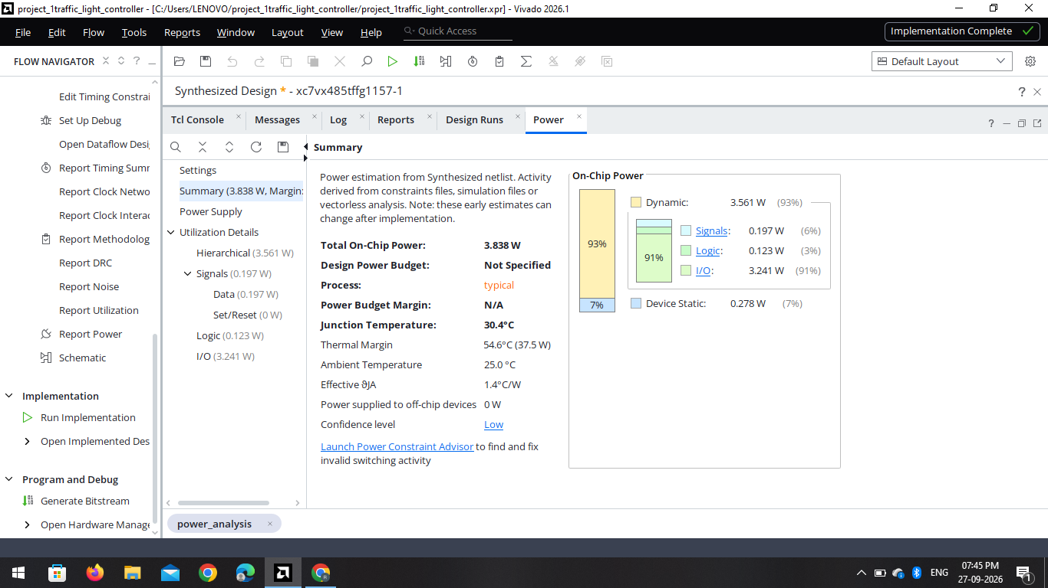
Figure 4: Power Analysis

